**EE 304 – Design Laboratory**

**Group No.** – 28

**Supervisor** - Prof. Harshal B. Nemade

**Names** –

* Aditya Uppala – 170108039 Ph.No:9025750599
* Srijan Sankrit – 170108046 Ph.No: 8294274400
* Sarvesh Arun Choushetti – 170108050 Ph.No:9421946025

**Project Title** – MEMS Based Bio Sensor

Aim and Introduction

The aim of this project is to create a Bio Sensor using **M**icro-**E**lectro**m**echanical **S**ystems (MEMS). This can be achieved using a SAW resonator (Surface Acoustic Wave resonator).

Due to its small size and wireless control, together with its multifunctional capabilities, label free and high accuracy make SAW devices a very promising component of biosensors. On one hand, SAW can be fabricated in a capsule and be planted into the inner body to access the body information we need wirelessly, such as inner body temperature mentioned before. On the other hand, the high accuracy makes it a perfect device for protein molecules, ultra-small cells or DNA detection.

Apparatus required

* YXC R433 **Surface Acoustic Wave** Resonator 433.33 MHz
* **0603**SMD Capacitors
* **0603**SMD Resistances
* 2SC4228 High Frequency Low Noise NPN Transistor
* 9V Battery for power supply
* Eagle Desk Software

Working of the SAW Resonator

A surface acoustic wave (SAW) is an acoustic wave traveling along the surface of a material exhibiting elasticity, with amplitude that typically decays exponentially with depth into the material. There are two kinds of SAW resonators: - One port SAW resonator and Two port SAW resonator. We use Two port resonator in our project.

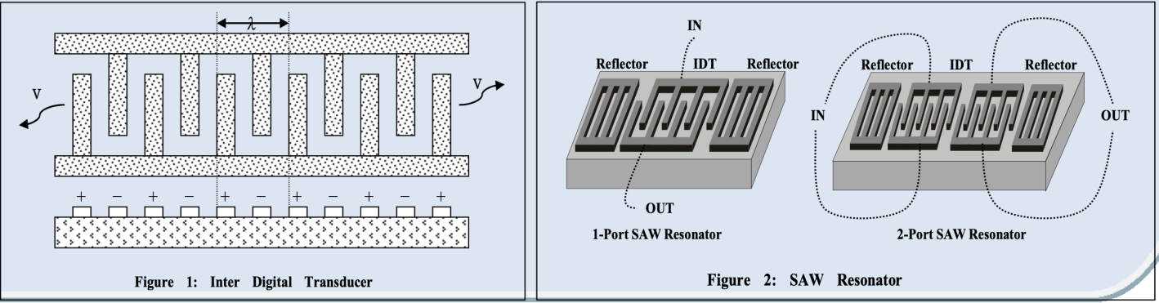

Surface Acoustic Wave is generated easily using  Inter Digited Transducers(IDTs). Surface acoustic waves are stimulated by applying a sinusoidal wave on the IDTs that are deposited on a **piezoelectric** material. The wave properties strongly depend on the substrate material, the shape of the IDTs, and the material deposited on the piezoelectric substrate.

External factors that can change the wave speed of the SAW using the thin layer deposited on the piezoelectric substrate on which the SAW is propagated. When analytes interact with this thin layer, either the electric field has a small difference, or a mass loading effect is introduced. In this way, the sensing of gases, chemicals, bio-molecules etc. is done, by sensing changes in conductivity of the sensing layer or by observing mass changes when specific molecules are absorbed. This kind of change is mostly measured by fabricating a kind of resonator and then measuring the change in the resonance frequency.

Progress Of the Project till Now

First, software necessary for designing the PCB was decided. We decided to use Eagle Desk for this. Then the required libraries for the components we were supposed to use were not there in the Standard Libraries of Eagle Desk. So we had to design these libraries ourselves. After this, the schematic design of the circuit was made and later the board layout was also made.

The libraries of the SAW resonator and the Transistor used were created.

Custom Library of SAW resonator (YXC R433)

Custom Library of transistor used (2SC4228 Transistor)

Schematic diagram of the Circuit

Board Layout

Future Work

Next, the board is printed and then the SMD components (Capacitors, Resistors and Inductors) are to be soldered properly at their appropriate positions. Then, the board will be tested for proper functionality. Once this is done, we will be proceeding to the next phase of our project, which is the calibrating phase. Here the change in frequency of the square wave generated by the SAW resonator is modified as it is required.